**Streaming IOT DATA to DynamoDB**

**ESP32:**

ESP32 is a low-cost, low-power Microcontroller with an integrated Wi-Fi and Bluetooth. It is the successor to the ESP8266

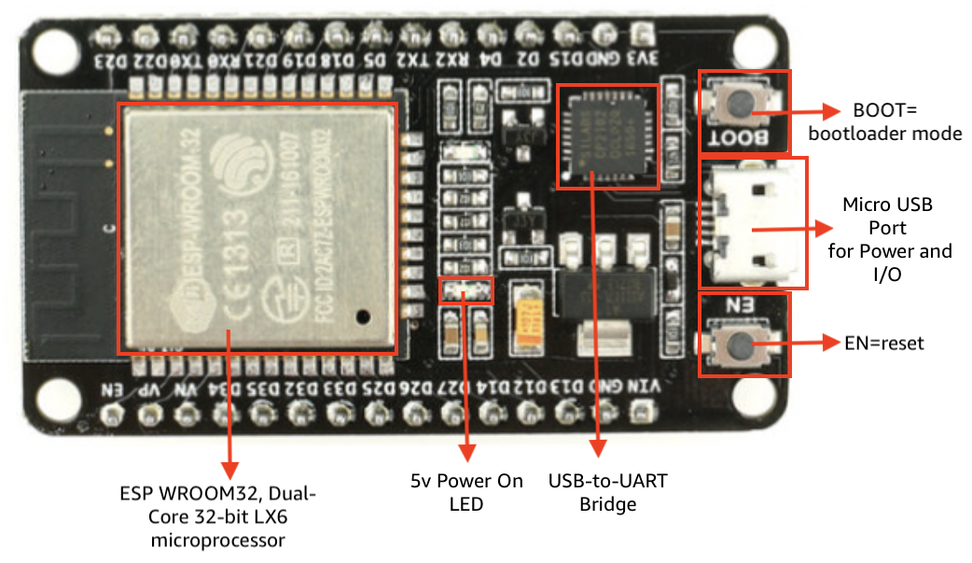

Prerequisites:

* AWS Free tier account. AWS services.(IOT Core, DynamoDB)
* ESP32 Controller
* DHT11
* Python/C ++
* Arduino IDE

The Arduino Integrated Development Environment - or Arduino Software (IDE) - contains a text editor for writing code. It connects to the Arduino hardware to upload programs and communicate with them.

Connection

|  |  |
| --- | --- |
| DHT11 | ESP32 |
| + | 3.3V |
| - | GND |
| Data( Middle Port) | D4 or any one (mentioned in code) |

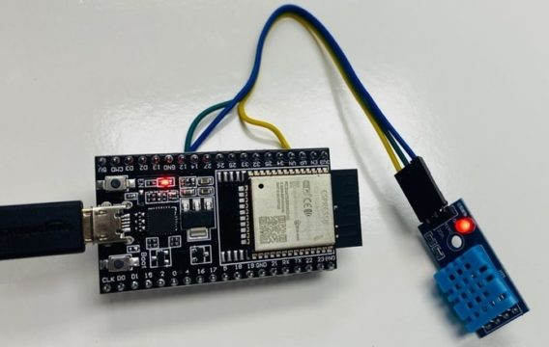

Architecture Diagram:

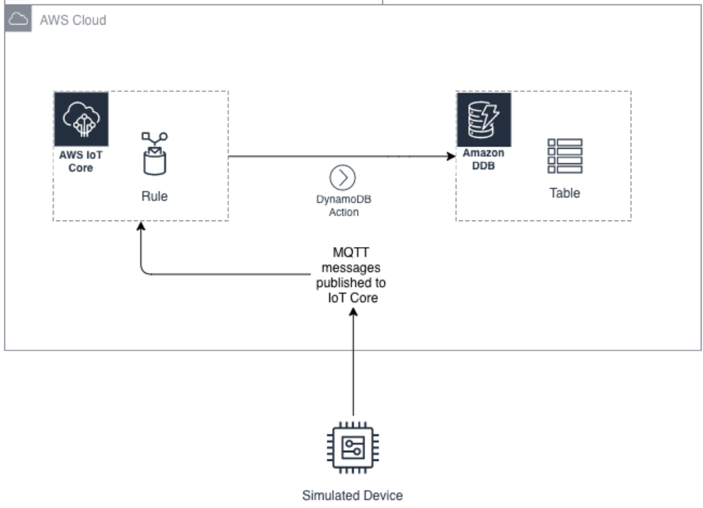

Task: Read the Temperature and humidity readings from DHT11 sensor and push it to AWS IOT core to and rule will then route it to the dynamo DB.

Create a DynamoDB table.

Create a Thing in the AWS IOT Core.

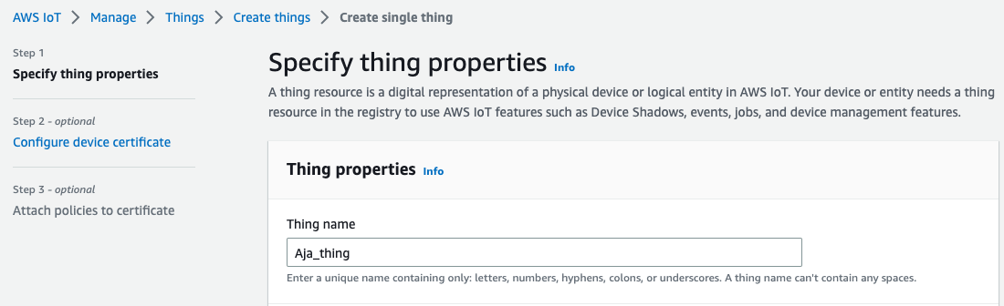

Create a policy that accepts all the topics(*), Create topic, publish topic, Subscribe topic.

End of thing creation. Download the certificates.

Details you needed for IOT device to publish message from code .

**Device Data Endpoint**: a3tdsfddfdfdfdf-ats.iot.us-east-1.amazonaws.com (AWS IOT 🡪 Settings)

**Thing Name: XYZ**

**ESP32 Needs your internet user name and password. It gets a private ip from the modem .**

**Certificates**

Publish the code to ESP32.

Look, I preferred to publish to the data to “**esp8266/pub**”. You can mention any name.

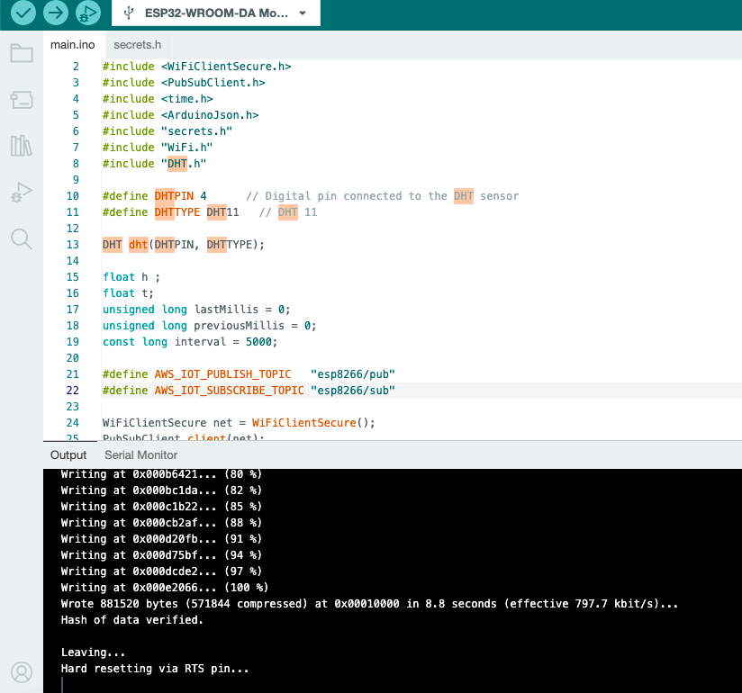

Once Code is pushed to the device. Device start sending the Temperature and Humidity Data.

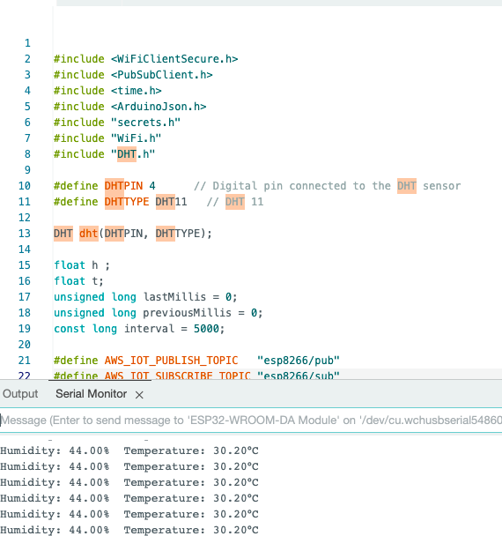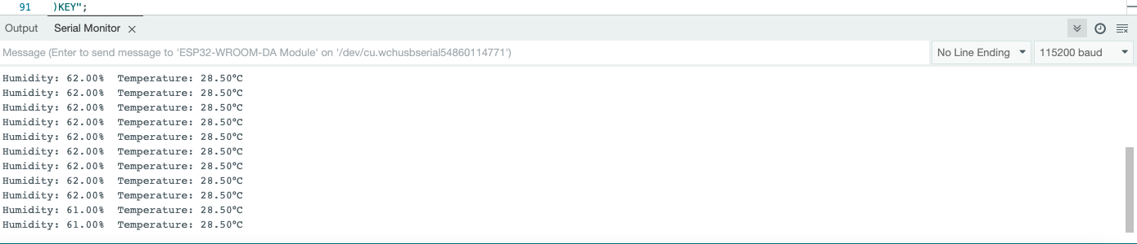

Source code is available here. <https://github.com/ThulasiKandhati/ESP32-DHT11-AWS>

You can also find the data in aws . Query with the topic.

You can also send messages to the device.

Create a rule to publish data to DynamoDB table.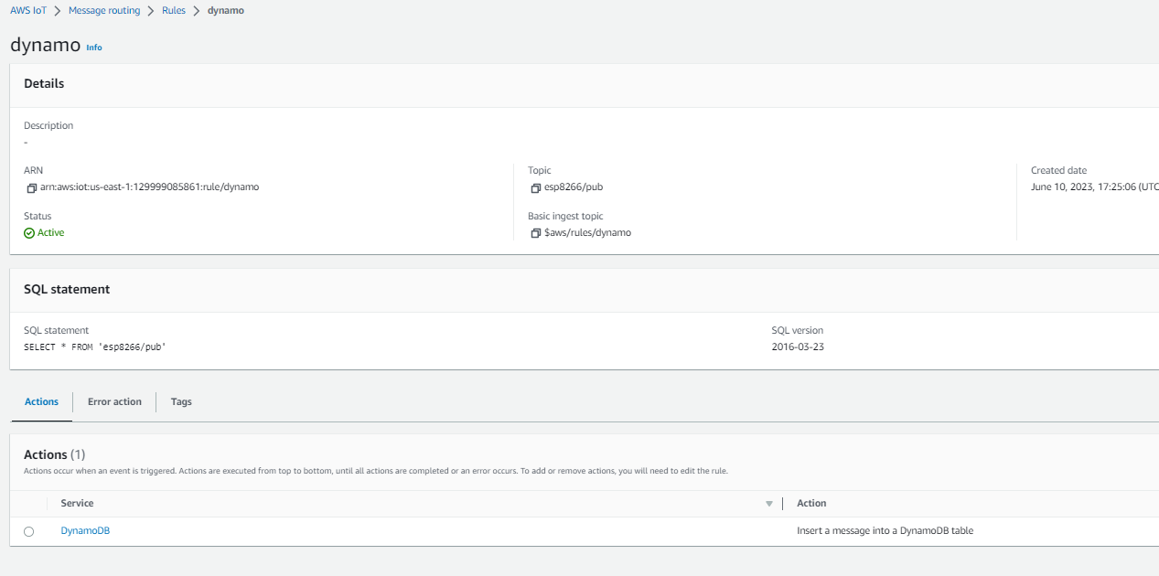

Query data from Dynamodb.

